Architecture Design
SUBARU - Production Scheduling Process



HTC Global Services
3270 W. Big Beaver Road, Troy
MI 48084
Phone: (248) 786 2500

Unit 31, SDF II, Phase II, MEPZ
Chennai - 600 045. India.
Phone: (44) 2262 3522/4783/5044

Document Number: | XXX\PD13\PRG\XXX_XXX | Version #: | 0.0a
Author | Karthikeyan.M | Signature:
Approved by |  | Signature:
Location of soft copy: | PPMA

Template Number | QLTY\QMS\TPL\ARCH_DES | Tpl Ver: | 1.8 | Protected | Rel Date | NOV_14_2013

“No part of this document may be reproduced or transmitted in any form or by any means electronic or mechanical including photocopying and recording or by any information storage or retrieval system except as may be expressly permitted.”
“Recipient of this document implicitly consent to this and also in consent with the applicable local privacy law”
“This softcopy is guaranteed to be the latest. If this document is printed, please cross reference to the version number indicated in the QMS Master List to avoid using an outdated version.”

Amendment Record

Version # | Description | Page # | Last Amended Date
V0.0a | Initial Documents Preparation | All | JUL-17-2015

Table of Contents
1. Introduction 6
2. Physical Environment 7
3. System Architecture 8
3.1 Triggering System 9
3.2 Spring Batch 9
3.3 Spring Batch Admin 10
3.4 DataSource 10
3.5 Exception Handling 10
4. Database Model: 12
4.1 CopyBook and Temporary Identifier Master Table 13
4.2 CopyBook Data Tables 15
4.3 Temporary Data Tables 16
4.4 Rules Table 17
4.5 Job Repository 18
4.6 Subaru Transaction Tables: 19
5. Spring Batch Features: 20
5.1 System Perspective: 20
5.2 Developer Perspective: 20
5.3 Financial Perspective: 20
6. Reference: 21

Introduction
Growing maintenance fees, scarcity of trained developers, expected end-of-life announcements, cumbersome deployment processes, platform dependencies – these are just a few reasons companies are migrating from legacy Mainframe COBOL applications to modern Java solutions.
Pulok comments: We cannot speculate or provide a generic statement reasoning why Subaru is moving to Java
Production Scheduling Process is a mainframe based legacy application to be converted from COBOL to Java application
Pulok comments: Cobol is just a programming language
This application is mainly used to prepare production data for weekly production planning of cars and the prepared production data will be an input for automated car manufacturing assembly points and other Subaru systems.
HTC’s proposed Production Scheduling Process application as batch job will help to automate the production lineup items efficiently through Java technology. The application will automate the job execution batch process using Spring Batch and Quartz scheduler.
HTC proposes to leverage J2EE platform to build the Production Scheduling Process for Subaru. The J2EE platform provides a proven, tested, and flexible approach to the proposed solution that will meet the business and technical requirements of Subaru.

Physical Environment
The physical environment in which this proposed system will be built and implemented are:
1) Core Java (JDK 1.6)
2) Spring Core
3) Spring Batch 3.0.4
4) Quartz Scheduler
5) DB2 Store Procedures and cursors
6) DB2 - Express C
7) Maven (artifactory)
8) Tortoise SVN
9) Log4j
10) Jboss Developer Studio 3.0.1 (IDE)
11) JBoss Application Server 5.0 (Application Server)
12) Apache POI (excel report generation)
13) Java Mailing Component
14) Spring MVC (Spring Batch Admin)
15) JSP, Javascript, Jquery, BootStrap (Spring Batch Admin)

System Architecture
The production schedule batch process architecture is diagrammatically represented below.
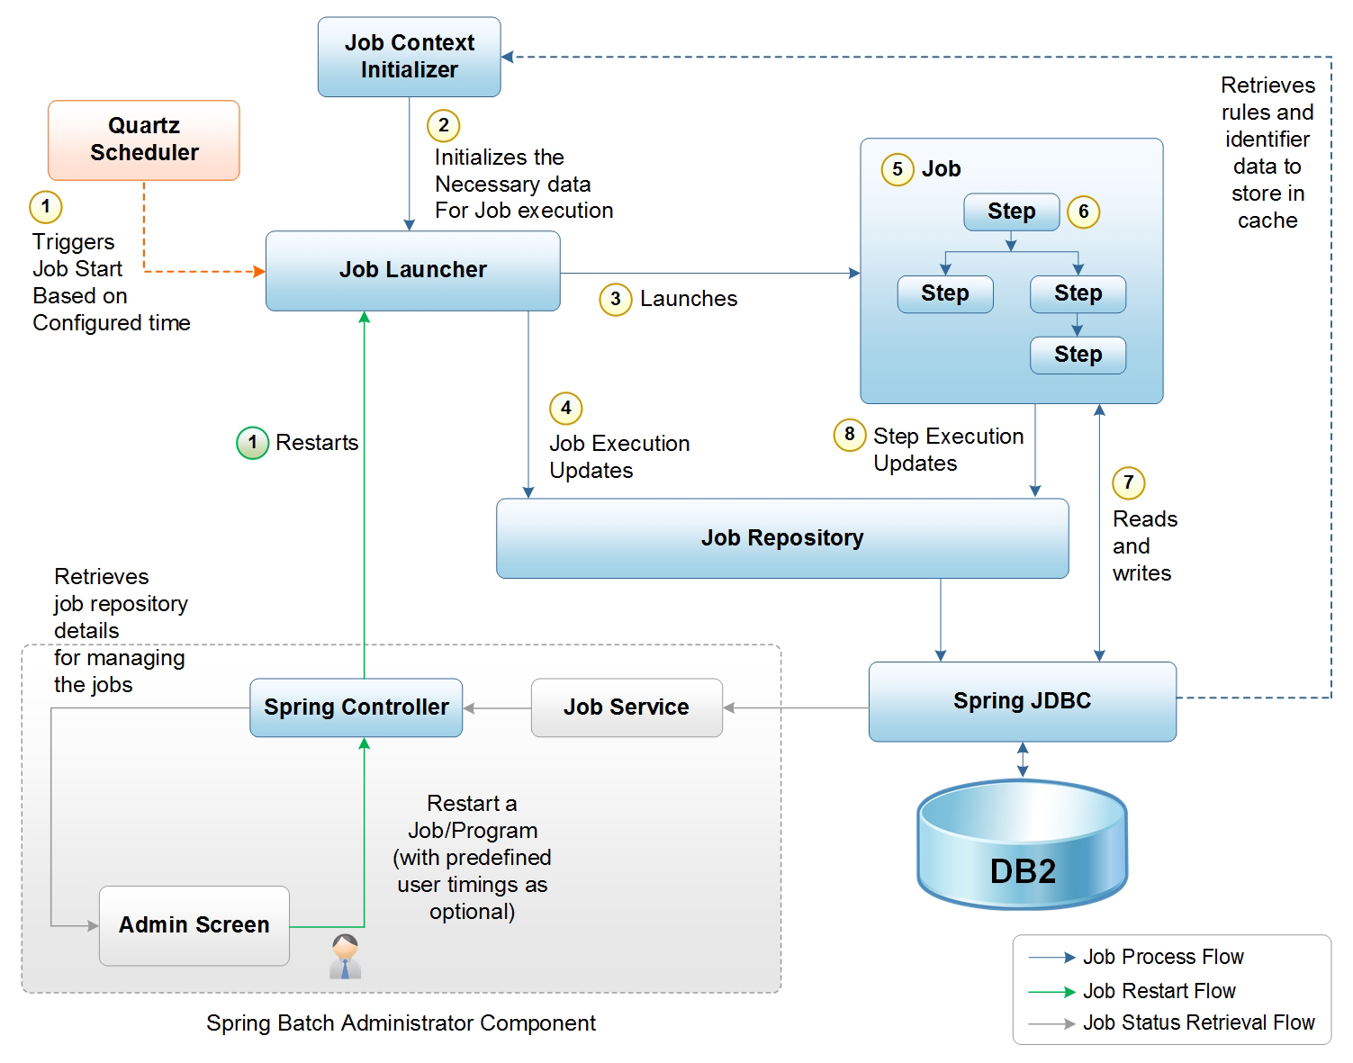
Figure 1: Production Scheduling Process Architecture Diagram

Triggering System
Quartz provides functionality for scheduling jobs. A common combination would be to use Quartz as a trigger for a Spring Batch job using a time bound expression and the Spring Core.

Spring Batch
A Job has one to many steps, which has exactly one reader, processor, and writer. A job needs to be launched (Job Launcher), and meta data about the currently running process needs to be stored (Job Repository).
A Job is an entity that encapsulates an entire batch process. As is common with other Spring projects, a Job will be wired together via an XML configuration file. This configuration may be referred to as the "job configuration".
A Job Instance refers to the concept of a logical job run.
JobLauncher represents a simple interface for launching a Job with a given set of JobParameters.
JobRepository is the persistence mechanism for all of the Stereotypes mentioned above. It provides CRUD operations for JobLauncher, Job, and Step implementations. When a Job is first launched, a JobExecution is obtained from the repository, and during the course of execution StepExecution and JobExecution implementations are persisted by passing them to the repository.
A Step is a domain object that encapsulates an independent, sequential phase of a batch job. Therefore, every Job is composed entirely of one or more steps. A Step contains all of the information necessary to define and control the actual batch processing. As with Job, a Step has an individual StepExecution that corresponds with a unique JobExecution.
ItemReader is an abstraction that represents the retrieval of input for a Step, one item at a time. When the ItemReader has exhausted the items it can provide, it will indicate this by returning null.
ItemWriter is an abstraction that represents the output of a Step, one batch or chunk of items at a time. Generally, an item writer has no knowledge of the input it will receive next, only the item that was passed in its current invocation.
ItemProcessor is an abstraction that represents the business processing of an item. While the ItemReader reads one item, and the ItemWriter writes them, the ItemProcessor provides access to transform or apply other business processing.

Spring Batch Admin
Provides a web-based user interface that features an admin console for Spring Batch applications and systems.
Once a job has executed, administrator can view the most recent executions, and a brief summary of their status (STARTED, COMPLETED, FAILED, etc.).
Each individual execution has a more detailed view (shown above), and from there the user can click down to a view of each of the step executions in the job (only one in this case). A common reason for wanting to do this is to see the cause of a failure.
Pulok comments: After reading the above paragraph. Seems like we can view the step executions in live – mode. This paragraph needs to be updated. It should depict that Admin user can view status of completed steps. Isn’t that’s the case?
The step execution detail view shows the history of the execution of this step across all job executions. This is useful for getting a statistical feel for performance characteristics. A developer running a job in an integration test environment might use the statistics here to compare different parameterizations of a job, to see what effect is of changing (for instance) the commit interval in an item processing step.
Pulok comments: If you are using the word called “Statistics” then you would need to incorporate at a high- level, what data points can be really viewed or captured or analyzed. I don’t think the Admin screen itself provides any feature for comparison. User may manually compare, correct???

DataSource
Only IBM DB2 will be the data source for this application.
Pulok comments: One sentence is not enough, you would need to mention that 9.1 Mainframes version is used by Subaru. You would also need to mention that for the development environment Windows 10.5 standalone versions have been installed. You may also mention that, before code is delivered, procedures written would be checked for DB2 compatibility issues.

Exception Handling
TODO:
<Specify all error messages that will be displayed by the product or system. Explain the circumstances in which each error message will occur and the action taken to rectify the error in the product or system. >
Pulok comments: Just mention that DB2 exception handling mechanism would be described in Program Specification document (Design document). After discussion with Subaru a similar mechanism to JCL Abends will be implemented.

JCL Files and their processing
Introduction:
The Java – Spring batch architectural design’s main premise is to move away from extensive file handling scenarios present in JCL. In that regard a unique concept is presented to Subaru. Files present in the JCL would be converted into tables.
Two types of files are available in JCL: Sequential (dataset) files and Generation Data Group.
Temporary sequential files (represented by WRK. And TMP. extensions) are used between the job steps for sort, copy and program operations. These are generally deleted when the process(es) in which they are required are completed.
If previous generation of a certain GDG base is accessed by any step then it is represented by (0). A step in JCL may create a new generation of a GDG base, it is represented by (+1).
Sequential files and GDGs have copybook structures which provide the meta – data information regarding the files.
The future architectural design will have tables instead of files. Table columns would mimic the copybook structure. Temporary files’ data of mainframes would be stored in Temporary data – copybook tables in new system. GDG files’ data of mainframes would be stored in GDG Data – copybook tables. Files of same copybook type would be stored in the same copybook table. Multiple generations data would be stored in the table with version identifier signifying the generations.
File and copybook relationship:
Copybook name will considered for naming the tables. To differentiate between a temporary dataset (file) and GDG if they are using the same copybook, additional table prefix and suffix would be added to the table name.
Copybook field levels:
Cobol copybooks uses levels 01, 02, 05, etc. in the structures. Since exact replica of levels is not possible to implement in DB2 table, after discussion with Subaru it will be determined which level copybook fields are most suitable to considered as table columns. Some amount of field aggregation may be required to implement.
Occurs clause:
Cobol copybooks also use ‘Occurs’ clause which is java equivalent of array sets. To handle such array sets, two approaches would be taken
- For a single occurs clause if the array sets are simple to implement then the data can be stored as series of table columns.
Consider an example where a 02- level field occurs 3- times. It has two 05- level fields
02 FIELD-NAME-X OCCURS 3 TIMES.
05 FIELD-NAME-Y PIC X (003).
05 FIELD-NAME-Z PIC X (002).
Assuming that in this copybook all other fields are present at 02-level and it is agreed to implement 02- level fields as table columns. It that case, Field-Name-X will be the column of table with length of 15 bytes.
FIELD-NAME-X
FIELD-NAME-Y | FIELD-NAME-Z | FIELD-NAME-Y | FIELD-NAME-Z | FIELD-NAME-Y | FIELD-NAME-Z
3 BYTES | 2 BYTES | 3 BYTES | 2 BYTES | 3 BYTES | 2 BYTES

- For complex and nested array sets present in copybook structure, it will not be possible to implement by approach # 1.
For nested array sets, more than one tables may be required to implement with foreign – key relationship with copybook table.
Redefines clause:
To implement redefines clause present in copybook structure, appropriate column datatype declaration would be utilized. If there are switches or constants used in redefines clause then the same switches or constants would be implemented while defining the table column.
Important points on copybook tables:
It should be noted that the copybook tables will generally be stand- alone tables. Except for copybook table where nested arrays are present and they have to be implemented using additional tables foreign – keyed to the main copybook table. Copybook fields would be converted into table columns but none of these columns will be the primary key for the table. The primary key of the copybook tables will be an additional column. It is proposed to index the tables based on the sort- keys generally used in the programs. Since sort functionality will be replaced by ‘Order By’ clause in java environment, indexed – by columns would lead to faster fetches.
GDG versions and generations:
GDG generations are defined by a combination of a generation and version numbers. In that regard, for the new system, a single term ‘version’ would be used. The data saved in the copybook tables for various generations of a particular GDG base can be differentiated using ‘Version Identifier’ column.
Maintaining generation index of a GDG:
Mainframes system maintain and increment the generation numbers automatically. Maximum number of generations present for GDG is determined by generation index, a number specified while the GDG base is created.
It needs to be discussed whether Subaru would like to implement a similar approach for versioned files. It is proposed that a table can maintain maximum number of versions required for each file. This count is similar to specifying a generation index. A weekly job can check the copybook tables for additional versions that the specified count and delete older versions of versioned files.
Benefits of implementing a table – based system rather than files:
- Mainframes systems rely mainly on file processing. The files are generally sorted and sorted files are taken as input. In Java world many of the steps involving downloading of table data and sorting the data for further processing can be avoided by table based approach.
- Sequential files are involved in JCL steps and many of them are temporary in nature. Generally these are deleted once the step execution is over. Separating the temporary data with GDG data storage will provide system ease in deleting such temporary data.
- Files use disposition parameters, so that the system may understand whether the file in a particular step is accessed, created or deleted. In java world we will use the same disposition parameters in a master table to take care of such requirements.
A more detailed discussion on these tables is continued into the next section of this document.

Database Model:
Subaru production scheduling process will consists of
- Copybook and Temporary Identifier Master Table
Pulok comments: Above name may be confusing to the Subaru team. A better name would be ‘File Identifier Master table’
- File Identifier Master Table: This table would hold information that is currently present in mainframes JCL. It would provide the reference for Spring batch which files are accessed or created for each step and their disposition
Pulok comments: Let’s go by a generic convention. There are two kinds of datasets. One type is GDG and other is sequential file
- GDG Copybook Data tables
- Temporary Data Sequential file Copybook tables
Pulok comments: I am removing the word ‘temporary data’ since some sequential files may not be temporary. Although we are yet to see such a dataset in PB100.
- Rules Table
- Job Repository Tables
- Subaru Transaction Tables

CopyBook and Temporary Identifier Master Table File Identifier Master Table
In Mainframe most of the job step data processing happens through a set of input and output copybook and temporary files. So in java, all the copybook and temporary file structures are moved to tables in order to avoid file handling.
Pulok comments: Please change the name of the table
The MAS_CPYBK_TEMP_IDENTF table holds all information relevant to the JCL files and their disposition parameters. In the new system these files are table data stored in copybook table. The information related to name of the copybook table will also be stored here.
This table will be referenced by the job for table processing.
copybook and temporary data tables and its application flow sequence. This table is like a kind of mater data table which holds the information all the job program related copybook and temporary data table names and what will be happen with that copybook record in case of processing. i.e. Whether to keep it after processing for future processing reference or to delete it . Every time a Job is run it will refer to this table data to get copybook processing information.

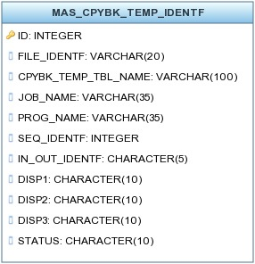

Below are descriptions of each column in the table:
FILE_IDENTF: String value to identify the exact records from the copybook and temporary data table GDG copybook and sequential file copybook tables
CPYBK_TEMP_TBL_NAME: String value representing the copybook and temporary data table name GDG copybook and sequential file copybook tables
Pulok comments: Column name can be simple TABLE_NAME
JOB_NAME: String value representing the job name of the batch process
PROG_NAME: String value representing the program name of a job
SEQ_IDENTF: Integer value representing the sequence flow of the application
Pulok comments: Would you be using the sequence identifier? Isn’t the sequence handled in spring – batch itself?
IN_OUT_IDENTF: String value representing whether this record is going to be input or output of that program
Pulok comments: I guess we can get away with In- Out – Identifier column also. If the first disposition is SHR, or OLD, or MOD then it’s the input. If the first disposition is NEW then its output. Check with Mahesh and Gayathri also.
DISP1: String value representing the current state of that particular record. i.e. NEW, OLD, SHR etc.
DISP2: String value to represent processed records to be kept or deleted in the copybook/temporary data table after successful program step execution.
DISP3: String value to represent processed records to be kept or deleted in the copybook/temporary data table in case of any exception and error.

CopyBook Data Tables
Pulok comments: Please change the name

In Mainframe most of the job step data processing happens through a set of input and output copybook and temporary files. So in java all the copybook and temporary file structures are moved to tables in order to avoid file handling.

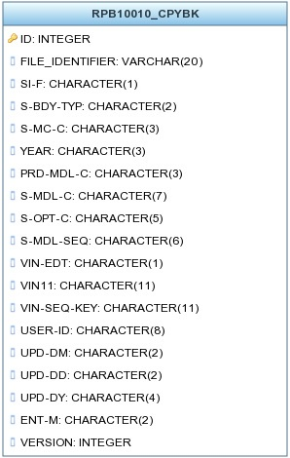
Below are descriptions of each column in the table:
FILE_IDENTF: String value to identify the exact records from the copybook and temporary data table
Data Columns: Copybook related columns
VERSION: Integer value representing the version number for set of records

Temporary Data Tables
Pulok comments: Please change the name
In Mainframe most of the job step data processing happens through a set of input and output copybook and temporary files. So in java all the copybook and temporary file structures are moved to tables in order to avoid file handling.

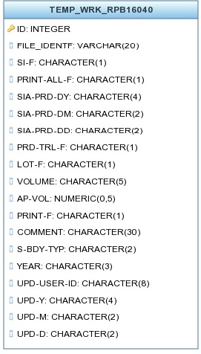
Below are descriptions of each column in the table:
FILE_IDENTF: String value to identify the exact records from the copybook and temporary data table
Data Columns: Copybook related columns

Rules Table
Rules table holds the conditional data related to specific jobs and programs

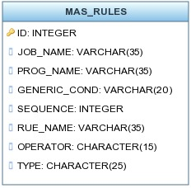
Pulok comments: In the table columns RUE_NAME instead of RULE_NAME is written. Please correct the typo.
Below are descriptions of each column in the table:
JOB_NAME: String value representing the job name of the batch process
PROG_NAME: String value representing the program name of a job
GENERIC_COND: String value representing the execution status of some other job – SUCCESS or if a processed record found in a copybook table – isNOTEMPTY
SEQUENCE : Integer value representing the condition framing sequence
RULE_NAME: String value representing rule name. Group of records related to a particular condition will share the same rule name
OPERATOR: String value representing the operator value like 'AND' 'OR'
TYPE: String value representing the whether that record belong to a condition or a result

Job Repository
These below mentioned job repository tables are related to job auditing and these are already inbuilt feature of spring batch.
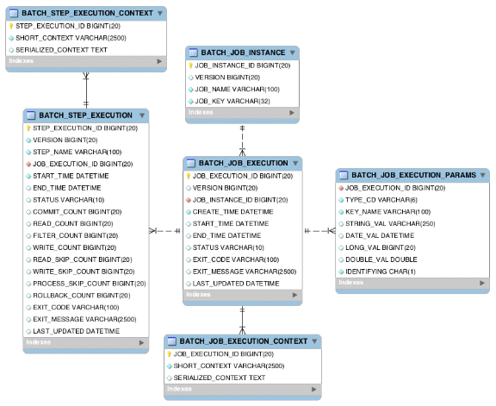

Subaru Transaction Tables:

These below mentioned Subaru transaction tables are already existing.

S.No | Table Name | Ts Name
1 | SOA_COLOR_CHG_XREF | CLRCHNGD
2 | CNTL_SEG_VON_SEQ | CTRLVOND
3 | FHI_SIA_DT_CNVR | FHISIADT
4 | LINEUP_VIN_SEQ_CNTL | LUPVINSQ
5 | ACM_MS3 | SACMMS3R
6 | SPCJSSTR | SPCJSSTR
7 | DAILY_BUILD_QTY | DLYBLDQD

Spring Batch Features:

System Perspective:
- Transaction management
- Chunk based processing
- Start/Stop/Restart
- Retry/Skip
- Web based administration interface (Spring Batch Admin)
- Commit batch process periodically
- Concurrent batch processing: parallel processing of a job
- Staged, enterprise message-driven processing (Scalable feature)
- Manual or scheduled restart after failure
- Sequential processing of dependent steps (with extensions to workflow-driven batches)
- Partial processing: skip records (e.g. on rollback)
- Job Auditing through JobRepository

Developer Perspective:
- Easy to configure, customize, and extend services, by leveraging the spring framework in all layers
- Batch developers use the Spring programming model: concentrate on business logic; let the framework take care of infrastructure
- Clear separation of concerns between the infrastructure, the batch execution environment, and the batch application
- Provide common, core execution services as interfaces that all projects can implement

Financial Perspective:
- Very stable open source framework

Reference:
http://docs.spring.io/spring-batch/trunk/reference/html/spring-batch-intro.html
http://spring.io/blog/2009/11/10/introducing-spring-batch-admin/
http://docs.spring.io/spring-batch/reference/html/metaDataSchema.html

